Job Description
Job Title | Senior Bid Manager
Location | Leeds, Hemel Hempstead, London, Hybrid

Role
The Senior Bid Manager will take ownership of a broad range of bids, proposals, and supporting collateral to drive sales growth across structured staffing solutions. In some instances, this will involve managing multiple concurrent bids and proactive proposals, requiring rigorous prioritisation, strong time management, and a disciplined, structured approach to planning. In others, the role will focus on leading complex, high-value, strategic bids, ensuring the development of competitive, fully compliant submissions.
They will be accountable for the timely delivery of high-quality tender responses, demonstrating exceptional written and verbal communication and a consistent focus on compliance and accuracy. Drawing on a proven track record within healthcare and public sector environments, they will leverage deep knowledge of NHS frameworks, procurement processes, and the healthcare recruitment landscape to develop compelling, compliant bids that support sustainable growth.
The Senior Bid Manager will also be responsible for supporting and guiding new starters and junior members of the team and must be able to demonstrate strong capability and commitment to developing others.
Working in close partnership with the Head of Bids and other colleagues across the Bid Team, the Senior Bid Manager will be a proactive and highly motivated self-starter, bringing the confidence, credibility, and professional gravitas needed to engage, influence, and collaborate effectively at all levels of the organisation.-starter, bringing the confidence, credibility, and professional gravitas needed to engage, influence, and collaborate effectively at all levels of the organisation.

Organisational structure
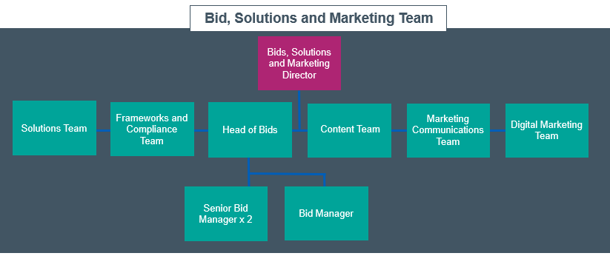
Responsibilities:
- Leading the end-to-end delivery of bids and proposals, from concurrent opportunities to complex, high-value strategic tenders, ensuring effective prioritisation, structure planning and fully compliant, competitive submissions.
- Providing support to Regional Workforce Service Directors and Service Line Leads through the management and production of sales and bid documentation
- Planning and prioritising bids and sales documentation
- Producing regular bid status reports and maintain accurate CRM records (Salesforce) to ensure transparent governance
- Close liaison with the Marketing & Brand team and taking an active role in the development and presentation of NHSP’s offerings
- Mentoring and supporting junior team members and new starters, fostering capability and knowledge sharing across the team
- Making sure all bid and proposal processes are run and delivered in accordance with the agreed process, and to prioritise viable and winnable opportunities
- Demonstrate critical thinking skills when reviewing tender specifications and interpreting and communicating opportunity and risk for the organisation
- Reviewing and understanding all criteria required for a compliant and low-risk submission
- Managing internal governance approval workstreams, liaising with stakeholders across operations, legal, compliance, implementation, technology, and finance.
- Networking, researching, and building relationships within the NHSP organisation to identify exciting and fresh new content, case studies, technology developments and new contract wins to support our propositions
- Writing and reviewing content, including (but not limited to) sales and marketing collateral, proactive proposals, and full and detailed formal, technical bid submissions
- Producing compelling bid and proposal collateral to contribute to NHSP’s growth
- Building excellent rapport with colleagues and (where appropriate) clients and striving to enhance the reputation of NHS Professionals with external stakeholders.

Accountabilities:
- Supporting Regional Workforce Directors and Service Line Leads to respond to new business and client retention opportunities
- The preparation, compliance and timely submission of major, often complex, bids and proposals
- Taking a proactive lead in developing, maintaining, and optimising bid management systems and processes, including the creation and continual improvement of a comprehensive bid library and supporting sales collateral
- Maintaining shared resources and content libraries
- Writing accurate and compelling content
- Working across the organisation to communicate and share learning from bid outcomes which assist in improvement and lessons learned analysis
- Protecting NHSP’s brand at all times
- Promoting optimal standards of professionalism and good business practice
- Ensuring compliance with NHSP’s financial and other policies, such as IT/information governance, HR
- Leading by example and in line with NHSP’s stated values, purpose and vision
- Providing cover for the team Senior Bid Manager, Bid Manager and deputising for the Head of Bids, and the Senior Bids & Senior Frameworks Compliance Manager where required

Experience and skills:
- Extensive experience of positive collaboration and influence with senior internal stakeholders, including Board, C-Suite and Senior Leadership Team members
- Experience of working within a dedicated bid function
- Able to demonstrate commercial awareness, critical thinking and a deep understanding of how a buyer’s specification requirements will translate into operational delivery
- Bid project mobilisation and delivery from end-to-end, on major £multi-million opportunities
- Using Microsoft programmes to create bid/sales collateral i.e. Word, PowerPoint, Visio, Teams, Share Point, Adobe Creative Suite (In Design)
- Driving digital innovation within bid processes e.g. utilising AI-enabled tools for workflow efficiency, knowledge management and collaboration

Key Values:
In addition to undertaking the duties as outlined above, the job holder will be expected to fully adhere to the following:
Equality and Diversity
Act in accordance with NHS Professionals’ Equality and Diversity Policy which is designed to prevent discrimination of any kind.

Health and Safety
Ensure that all duties are carried out in line with NHS Professionals’ Health and Safety Policy.

Corporate Image
Adopt a professional image at all times.

Risk Management
Responsibility for reporting complaints, incidents and near misses through the Complaints and Incidents Management System
Responsibility for attending health and safety training as required
Responsibility for assisting with risk assessments

Scheme of Delegation
To comply the Scheme of Delegation this requires any employee to declare an interest, direct or in-direct, with contracts involving the organisation.

Note
This job description outlines the roles, duties and responsibilities of the post. It is not intended to detail all specific tasks.

Acceptance

I agree to undertake the duties of the job in accordance with the above

Signed:..……………………………………..… (Job Holder)

Name: ……………………………………………… (Print)

Date: ……………….

Signed: …………………………………………… (Line Manager)

Name: ……………………………………………... (Print)

Date: ……………….

PERSON SPECIFICATION
Attributes/Skills | Essential  (When applying for this job it is important you fulfil all these essential requirements. If you do not you are unlikely to be interviewed) | Desirable  (When applying for this job it is desirable you fulfil these requirements. However, if you do not you may still apply and may be interviewed) | Measurement  A / C / P / R / T
Qualifications & Knowledge | - Relevant degree, professional qualification or equivalent  - Knowledge of public sector procurement regulations and frameworks | - Knowledge of the NHS or wider healthcare sector  - Knowledge of recruitment process outsourcing, including volume/campaign hiring  - Direct sales experience | A / C / I / T / R
Experience | - Proven and successful background in bid management at senior level  - Experience of mentoring other team members  - Management of multiple complex bid/proposals  - Writing and reviewing compelling, accurate and winning bid/proposal content  - Production of visually engaging graphics and presentations  - Extensive experience of positive collaboration and influence with senior internal stakeholders, including Board, C-Suite and Senior Leadership Team members  - Experience of working within a dedicated bid function  - Bid project mobilisation and delivery from end-to-end on major £multi-million opportunities | - Project Management, including risk management and mitigation  - Experience of using the Salesforce CRM platform | A / R / I
Communication & People Skills | - Polished presentation, oral and written skills  - Able to build and maintain effective professional interpersonal relationships, offering constructive feedback and challenge in a positive manner  - Able to positively influence at all levels of the organisation  - Demonstrable negotiation skills | - Demonstrable ability to understand, analyse and use strategies to gain new business | A / I / T / R
Organisational Skills | - A motivated self-starter, accountable for own workload  - Organised and structured  - Able to time manage own workload  - Able to manage multiple workstreams and stakeholders, often to tight deadlines under time pressures | - Aware of the political and organisational environment in which the NHS operates | A / I / R
Specialist Knowledge &  Skills | - Commercially astute  - Excellent standard of written English, with ability to clearly articulate win themes and benefits  - Numerate and with accurate data and reporting skills  - A genuine curiosity to learn, and to proactively put forward ideas for continuous improvement  - Ability to research, analyse and interpret complex data and information  - Familiar with the range of online procurement portals typically used in public sector tendering processes  - Able to demonstrate commercial awareness, critical thinking and a deep understanding of how a buyer’s specification requirements translate into operational delivery  - Using Microsoft programmes to create bid/sales collateral (Word, PowerPoint, Visio, Teams, SharePoint) and Adobe Creative Suite (InDesign)  - Driving digital innovation within bid processes, including utilising AI-enabled tools for workflow efficiency, knowledge management and collaboration | - Knowledge of medical and clinical staffing programmes  - Knowledge of the NHS purchasing environment | A / I / R / T
Physical Skills | - Able to pass pre-employment checks  - Able to travel with some overnight stays |  | P
Equality | - Candidates should indicate an acceptance of and commitment to the principles underlying NHS Professionals’ Equality and Diversity and Health and Safety Policies. |  | A / I

A = Application Form
C = Certificate
I = Interview
P = Pre-employment health screening
R = References
T = Tests/ presentation

Key: A = Application Form C = Certificate I = Interview P = Pre-employment health screening R = References T = Tests/presentation

