Job Description
NHS Professionals

Job Title Governance and Paralegal Assistant
Grade tbc
Location Hemel Hempstead/ Leeds/Manchester
(Ability to work remotely -Travel and overnight stays may be required)

Role Summary

The Company Secretary looks after all NHSP’s Legal, Compliance, Governance, Risk management, Internal Audit, Data Protection, Company Secretarial and Governance.
The Governance and Paralegal Assistant will be responsible for providing support to the Senior Governance Paralegal Assistant to ensure all NHSP’s secretariat, corporate governance, legal and compliance functions are completed effectively and efficiently. This new role will have exposure to all parts of the business and be a part of NHSP’s governance arrangements.

Organisational Position (Illustrative)
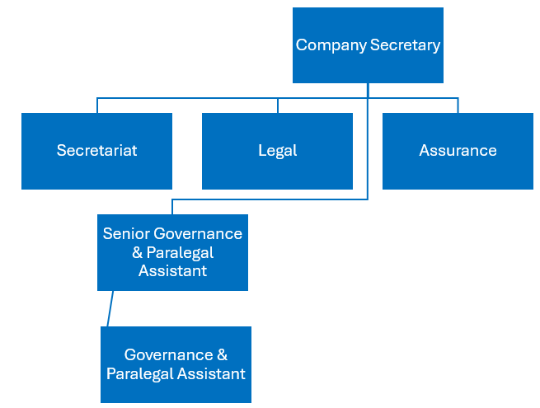

Key Responsibilities & Accountabilities

Governance/ Company Secretarial
- The key responsibility of this role will be supporting the Senior Company Secretarial Assistant in the effective and efficient provision of secretariat services to the Board, its sub-committees and the Executive Team including preparing agendas, co-ordinating the production of papers and minutes, record-keeping and ensuring that there is effective follow through on all relevant matters arising and action points.
- Attending meetings of the NHSP Board and its committees and taking minutes where required
- Delivering a comprehensive range of support activities, proactively troubleshooting and resolving issues which arise to allow the Secretariat to deliver in line with expectations
- Working with the Company Secretary’s EA and CEO’s EA to ensure that all relevant scheduling activities are carried out, including organising all aspects of NHSP Board and other meetings and ensuring all involved are aware of upcoming commitments and responsibilities
- Collating, reviewing and preparing a range of papers and correspondence, proactively identifying and distilling pertinent issues where appropriate
- Managing projects, researching and preparing appropriate reports or presentations independently
- Researching, prioritising and following up on incoming issues and concerns for the Secretariat
- Reviewing and improving operating practices within the Secretariat to ensure it operates to its optimum
- Set up and manage agreed communication system and protocols to ensure consistent standards in all communications from the Secretariat

Paralegal

- Conduct legal research on various topics, providing summaries and reports to the legal team.
- Draft and review contracts, agreements, and other legal documents.
- Assist in the preparation of regulatory filings
- Support the legal team in managing case files, including organizing documents, tracking deadlines
- Liaise with external counsel and other stakeholders on ongoing contracts and legal matters.
- Provide general administrative support to the legal department

Key Values:
In addition to undertaking the duties as outlined above, the job holder will be expected to fully adhere to the following:
- Equality and Diversity
To act in accordance with NHS Professionals’ Equality and Diversity Policy - this is designed to prevent discrimination of any kind.
  - Health and Safety
Ensure that all duties are carried out in line with NHS Professionals’ Health and Safety Policy.
    - Corporate Image
Always adopt a professional image.
- Risk Management
Responsibility for reporting complaints, incidents and near misses through the relevant channel.
Responsibility for attending health and safety training as required.
Responsibility for assisting in risk assessments.

- Scheme of Delegation
To comply with the Scheme of Delegation - this requires any employee to declare an interest, direct or in-direct, with contracts involving the organisation.

Note:
- The role may require some travel and overnight stays.
- This job description outlines the roles, duties and responsibilities of the post. It is not intended to detail all specific tasks.
PERSON SPECIFICATION

Criteria | Essential  (When applying for this job it is important you fulfil all these essential requirements.  If you do not you are unlikely to be interviewed) | Desirable  (When applying for this job it is desirable you fulfil these requirements. However, if you do not, you may still apply and may be interviewed)
Qualifications and Knowledge: | - Bachelor’s Degree in Business Admin, law or related field, or equivalent qualification/experience  - Knowledge gained through degree or equivalent experience, plus further training and experience | - Training qualification  - Evidence of continued commitment to personal development
Experience: | - Significant experience in a similar role (18 months- 3 years) | - Experience in a company secretarial role and/or as a paralegal  - Managing corporate governance and compliance tasks
Communication and People Skills: | - Ability to communicate across the organisation  - Maintain confidentiality and handle sensitive information with integrity  - Attention to detail
Organisational Skills | - Highly organised and able to work independently  - Ability to manage multiple priorities and deadlines
Specialist Knowledge and Skills | - Minute taking
Physical Skills: | Must pass pre-employment health assessment.
Equality | Candidates should indicate an acceptance of and commitment to the principles underlying NHSP’s Equality and Diversity and Health and Safety Policies.

