Job Description
NHS Professionals Ltd

Job Title: | IT Procurement Manager
Grade: | SME 3
Location: | Hemel, Manchester, Leeds, Agile

Role:

To manage the strategic procurement and contract management of IT-related categories, with a focus on software licensing, hardware, professional services, and contingent labour. The role involves managing IT spend while ensuring compliance, cost efficiency, and value for NHS Professionals (NHSP). Reporting to the Head of Procurement, the role will involve the close management of key suppliers and collaboration with internal stakeholders to deliver IT procurement strategies.

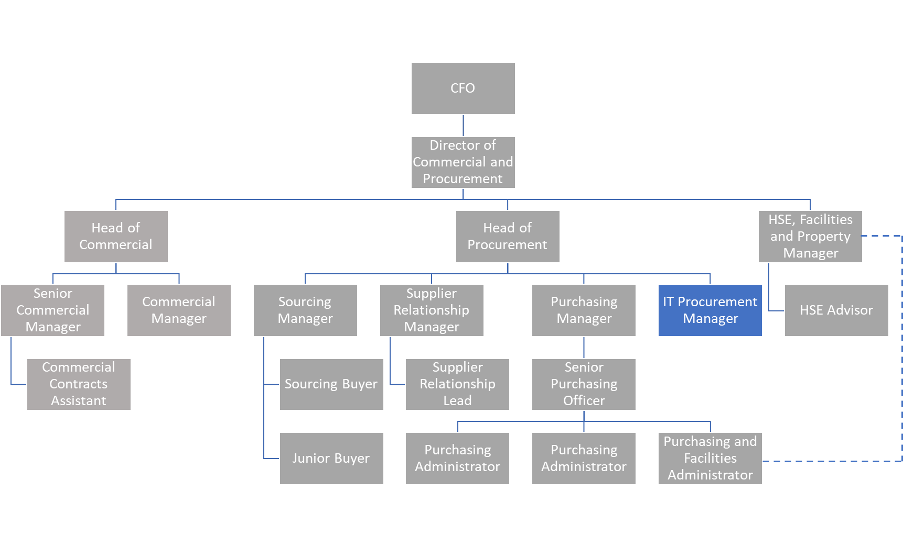
Organizational Structure:

Responsibilities:

- Manage the end-to-end procurement of IT goods and services, focusing on licensing agreements, IT infrastructure, and technology-related services.
- Lead the planning and execution of IT sourcing strategies, ensuring alignment with business objectives and value maximization.
- Negotiate and manage contracts for IT vendors, ensuring optimal licensing terms, renewal management, and compliance with legal standards.
- Oversee and control contingent labour and professional services spend within the IT category, ensuring adherence to approved budgets.
- Collaborate with IT departments and key stakeholders to ensure a clear understanding of future business needs and technology trends.
- Develop and implement IT procurement policies and procedures, ensuring consistent best practices across the organization.
- Maintain up-to-date records of IT procurement activities, including contracts, spend tracking, supplier performance, and licensing compliance.
- Identify opportunities to improve value through vendor consolidation, cost reductions, or enhanced service levels.
- Drive continuous improvement in procurement processes, utilizing insights from benchmarking and industry standards.

Accountabilities:

- Ensure IT procurement achieves cost savings against agreed targets, without compromising on service quality.
- Manage relationships with key IT suppliers, in collaboration with the Supplier Relationship Management (SRM) team and functional stakeholders.
- Engage with key internal stakeholders to build strong relationships and identify value-added business opportunities.
- Ensure professional procurement processes are followed, supporting team members in developing negotiation strategies.
- Maintain up-to-date records on category spend, supplier management, and contract databases.
- Track and report on savings, spend, and usage, keeping all stakeholders informed of key procurement metrics.

Key Values:

In addition to undertaking the duties as outlined above, the job holder will be expected to fully adhere to the following:

- Equality and Diversity
To act in accordance with NHS Professional’s Equality and Diversity Policy, this is designed to prevent discrimination of any kind.
  - Health and Safety
Ensure that all duties are carried out in line with NHS Professional’s Health and Safety Policy.
    - Corporate Image
Adopt a professional image at all times.
- Risk Management
Responsibility for reporting complaints, incidents and near misses through the Complaints and Incidents Management System (CIMS)
Responsibility for attending health and safety training as required.
Responsibility for assisting in risk assessments.

- Scheme of Delegation
To comply the Scheme of Delegation this requires any employee to declare an interest, direct or in-direct, with contracts involving the organisation.
Note:

This job description outlines the roles, duties and responsibilities of the post. It is not intended to detail all specific tasks.

Person Specification:

Criteria: | ESSENTIAL  (When applying for this job it is important you fulfil all these essential requirements. If you do not you are unlikely to be interviewed) | DESIRABLE  (When applying for this job it is desirable you fulfil these requirements. However, if you do not you may still apply and may be interviewed)
Qualifications and Knowledge: | - Degree or equivalent qualification in procurement, supply chain management, or IT (e.g., CIPS or equivalent).  - In-depth knowledge of IT procurement processes, including software, hardware, and IT services procurement.  - Working knowledge of public sector procurement regulations, with specific emphasis on IT procurement.  - Familiarity with Microsoft Dynamics for purchasing and invoicing, and Arcus for supplier management.  - Knowledge of IT contract management, including licensing agreements, SaaS, and cloud services. | - Further qualifications in IT management or a related field (e.g., ITIL, project management certifications).  - Advanced procurement certifications (e.g., CIPS Level 6).
Experience: | - Proven experience in IT procurement within a large organisation, ideally in a healthcare or public sector environment.  - Significant experience managing procurement for IT projects, including software licenses, hardware acquisitions, and IT service contracts.  - Experience negotiating with IT suppliers and vendors, including managing supplier performance and contract compliance.  - Familiarity with procurement systems like Microsoft Dynamics and Arcus.  - Demonstrable experience working on high-value and complex IT procurement projects. | - Experience working within the NHS or healthcare sector, particularly in IT procurement.  - Experience managing procurement for digital transformation initiatives, including cloud migration or automation projects.
Communication and People Skills: | - Strong communication skills, with the ability to effectively engage and influence senior stakeholders, including IT teams, legal, and finance departments.  - Ability to negotiate and build relationships with external IT suppliers.  - Collaborative and able to work across different teams to deliver procurement objectives aligned with IT strategies.
Organisational Skills | - Strong project management and organisational skills, with the ability to manage multiple IT procurement projects simultaneously.  - High level of attention to detail, particularly in managing IT contracts and procurement documentation.  - Ability to develop and implement IT procurement strategies that align with organisational goals.
Specialist Knowledge and Skills | - Expertise in IT procurement, including understanding market trends, supplier performance metrics, and cost-saving opportunities in the IT space.  - Knowledge of risk management in IT procurement, particularly related to cybersecurity, data protection, and compliance.  - Proficient in Microsoft Office (Excel, Outlook, PowerPoint) and IT procurement tools, including Microsoft Dynamics and Arcus. | - Knowledge of the NHS  - Familiarity with NHS IT systems, NHS Digital standards, and public healthcare IT procurement challenges.  - Experience working with IT suppliers on long-term projects and managing service-level agreements (SLAs) for IT services.
Physical Skills: | - Must pass pre-employment health assessment.
Equality: | - Candidates should indicate an acceptance of and commitment to the principles underlying NHSP’s Equality and Diversity and Health and Safety Policies.

