Job Description
NHS Professionals

Job Title National Service Centre Manager
Grade <tbc>
Location Hemel Hempstead
(Ability to work remotely)

Role Summary

Leading the contact centre management team to provide a first class, professional, high quality, customer contact through a variety of customer contact channels to maximise the performance of the Service Centre against defined KPI’s. Playing a key leadership role in ensuring Workers, Clients and Applicants are supported when contacting NHSP.

Organisational Position

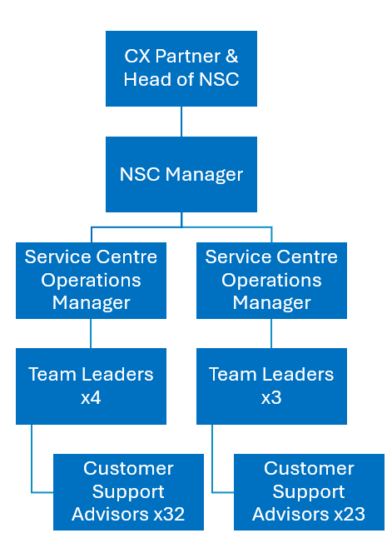

Key Responsibilities
• To play a key role in managing the Service Centre through change adoption and implementation of key improvement initiatives
• Managing the NSC operational Managers in line with the business objectives and ensuring all teams performance targets and deliverables are met.
• To own the provision of service for on shore and offshore teams, identifying gaps in service provision & knowledge and defining recovery plans with the Operations Managers
• Working closely with the Resource Planning Manager to assess resource requirements based on forecasts to ensure the Service Centre can maintain performance levels within budgetary tolerances
• To ensure that business risk or change is identified, and any changes reported are planned and controlled effectively, without compromising the stability of the operation
• Analysing and assessing Service Centre performance data to improve service provision and maintain consistent, high levels of customer satisfaction.
• Determining Service Centre operational strategies by conducting needs assessments, performance reviews, capacity planning and production, productivity, quality and customer service standards, contributing information and analysis to organisational strategic plans and reviews
• To ensure Operations managers and Team Leaders are delivering the mentoring, coaching and feedback of key performance indicators, setting objectives with individuals and reviewing monthly in line with business objectives
• For maintaining quality standards across the Service Centre, ensuring all assurances activities are conducted in line with NHSP standards and any remedial actions are taken as appropriate
• Supporting Operations Managers and Team Leaders to manage all people/performance situations effectively and sensitively in line with HR policies & procedures.
• Create, build, and maintain relationships with designated senior stakeholders and internal departments, to ensure service issues are identified and resolutions implemented in a timely manner
• Managing attrition and subsequent recruitment activities to ensure the service is appropriately staffed in line with budgetary constraints and resource planning forecasts
• Supporting the IAO (Information Asset Owner) for the Service Centre, attending key meetings when required and accountable for implementing any remedial tasks required to maintain compliance
• For ensuring the Operational Business Continuity of the Service Centre, leading on any business evocations and/or internal incidents. Contributing to the departmental & overall business continuity plan
• Working constructively and consistently with Team Managers, identifying service improvements, and implementing new operational processes, supporting high standards of delivery within the Service Centre
• Working collaboratively with the Resource Manager to ensure the secure long-term planning of the Service Centre, meeting capacity and productivity requirements and highlighting any variance outside of tolerance
• Requirement to participate in an on-call rotation to ensure uninterrupted support and efficient handling of critical issues outside regular business hours.

Key Accountabilities

• For deployment of Service Centre teams nationally, ensuring service provision is of a consistently high standard
• To act as the Senior Manager for formal disciplinary investigations, as investigating manager or chair as appropriate
• Accountable for the Service Centre’s financial budget, ensuring all costs (project, resource, meetings, training, etc.) are managed and are escalated if outside of agreed tolerances
• Analyse operational performance data including identification and monitoring of KPI’s & SLA’s, against predetermined objectives and agree procedure for improvements
• Assist in developing and lead on the delivery of the Service Centre people strategy, ensuring a people focused culture is embedded within the function through all levels of management and frontline staff
• Work with the Quality Assurance manager to ensure all remedial actions for service improvements are acted upon, promoting consistency across the Service Centre.
• Work with Operations Managers to identify skills gaps where additional mentoring and training may be needed
• Work with the Resource Planning and Manager and resource analysts to ensure real-time delivery of in-day service metrics in line with agreed Service Levels
• Lead Operation Managers in taking intra-day remedial actions to maintain Service Levels whilst proactively planning and supporting near-term resourcing activities
• Ensure information held within the remit of the Service Centre is accurate and handled in line with General Data Protection Regulation (GDPR) regulations
• Accountable for ensuring training of all staff is appropriate and all mandatory and statutory training obligations are adhered to.
• Responsible for carrying out annual appraisals for direct reports and ensuring all appraisals are complete across the Service Centre teams consistently and in line with NHSP annual appraisal policies and procedures
• Support and guide Managers and/or Team Leaders in recognising when performance is not being achieved, ensuring timely and appropriate action is taken in line with the Performance Management guidelines
• Deputise for Customer Experience Partner and Head of NSC in their absence

Key Values:
In addition to undertaking the duties as outlined above, the job holder will be expected to fully adhere to the following:
- Equality and Diversity
To act in accordance with NHS Professionals’ Equality and Diversity Policy - this is designed to prevent discrimination of any kind.
  - Health and Safety
Ensure that all duties are carried out in line with NHS Professionals’ Health and Safety Policy.
    - Corporate Image
Always adopt a professional image.
- Risk Management
Responsibility for reporting complaints, incidents and near misses through the relevant channel.
Responsibility for attending health and safety training as required.
Responsibility for assisting in risk assessments.

- Scheme of Delegation
To comply with the Scheme of Delegation - this requires any employee to declare an interest, direct or in-direct, with contracts involving the organisation.

Note:
- This job description outlines the roles, duties and responsibilities of the post. It is not intended to detail all specific tasks.
PERSON SPECIFICATION

Criteria | Essential  (When applying for this job it is important you fulfil all these essential requirements.  If you do not you are unlikely to be interviewed) | Desirable  (When applying for this job it is desirable you fulfil these requirements. However, if you do not, you may still apply and may be interviewed)
Qualifications and Knowledge: | • Educated to degree level or equivalent experience  • Evidence of CPD | • Certification in Call Centre Management or equivalent
Experience: | • 3-5 years Demonstrable experience of managing within a multi-channel Service Centre environment.  • Evidence of analysing and producing detailed management information.  • Management performance experience  • People development experience  • Experience of working in a target driven environment  • IT literate, including proficient use of Microsoft applications, Word, Excel and PowerPoint  • Evidence of planning & resourcing in a Service Centre environment  • Understanding & experience of Quality Assurance practices | • Experience managing complaints
Communication and People Skills: | • Strong influencing skills at all levels  • Evidence of strong people management skills and ability to lead and work supportively as part of a team  • Calm, approachable and confident when dealing with challenging situations and key stakeholders.  • Ability to influence, persuade, negotiate, delegate, prioritise and organize multiple concurrent tasks  • Experience in delivering high level presentations to a diverse group of people  • Ability to build effective working relationships with staff across a wide range of professional and managerial groups  • Excellent verbal, written and interpersonal communication skills  • Able to motivate and develop team managers  • Adaptable to change in a high-pressure environment/situation  • Ability to provide constructive feedback at all levels
Organisational Skills | • Ability to work cohesively/ collaboratively within wider management team and staff representatives  • Ability to work under pressure and consistently meet tight deadlines and offer practical solutions  • Ability to lead and work supportively as part of a team  • Flexible & adaptable approach to work  • Ability to deliver projects on time & within budget  • Make decisions based on commercial awareness
Specialist Knowledge and Skills | • In depth understanding of contact centre technologies  • Able to use a wide variety of IT software including database management  • Strong influencing and negotiation skills  • Ability to motivate and develop a team of staff  • Adaptable to change  • Good presentation skills | • Strong strategic, analytical, investigative and problem-solving skills  • Good report writing skills
Physical Skills: | Must pass pre-employment health assessment.
Equality | Candidates should indicate an acceptance of and commitment to the principles underlying NHSP’s Equality and Diversity and Health and Safety Policies.

