Job Description
NHS Professionals

Job Title Senior Governance and Paralegal Assistant
Grade tbc
Location Hemel Hempstead/ Leeds/Manchester?
(Ability to work remotely -Travel and overnight stays may be required)

Role Summary

The Company Secretary looks after all NHSP’s Legal, Compliance, Governance, Risk management, Internal Audit, Data Protection, Company Secretarial and Governance.
The Senior Governance and Paralegal Assistant will be responsible for providing support to the Company Secretary to ensure all NHSP’s secretariat, corporate governance, legal and compliance functions are completed effectively and efficiently. This new role will have exposure to all parts of the business and be a part of NHSP’s governance arrangements.

Organisational Position (Illustrative)
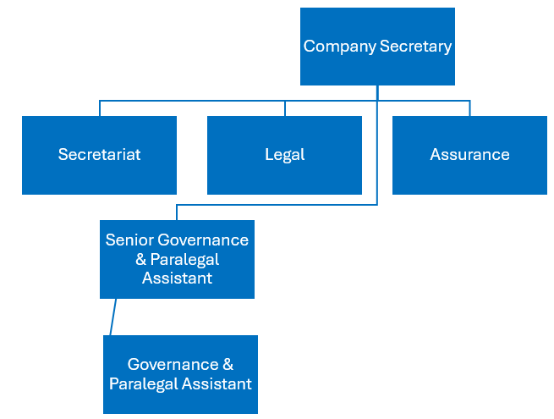

Key Responsibilities & Accountabilities

Governance/ Company Secretarial
- The key responsibility of this role will be supporting the Company Secretary in the effective and efficient provision of secretariat services to the Board, its sub-committees and the Executive Team including preparing agendas, co-ordinating the production of papers and minutes, record-keeping and ensuring that there is effective follow through on all relevant matters arising and action points.
- Attending meetings of the NHSP Board and its committees and taking minutes where required
- Delivering a comprehensive range of support activities, proactively troubleshooting and resolving issues which arise to allow the Secretariat to deliver in line with expectations
- Facilitate and manage governance functions such as board recruitment, induction and evaluation for regional boards and coordinate arrangements for board meetings to ensure effective management
- Effective line management responsibility of Governance and Paralegal Assistant
- Deputising for the Company Secretary where required
- Working with the Company Secretary’s EA and the CEO’s EA to ensure that all relevant scheduling activities are carried out, including organising all aspects of NHSP Board and other meetings and ensuring all involved are aware of upcoming commitments and responsibilities
- Communicating directly, and on behalf of the Company Secretary, with Board, ExCo/SLT members and others
- Collating, reviewing and preparing a range of papers and correspondence, proactively identifying and distilling pertinent issues where appropriate
- Appropriately handling correspondence and documentation for the Secretariat, including financial reports and documentation of a sensitive or confidential nature using a high degree of discretion
- Managing projects, researching and preparing appropriate reports or presentations independently
- Researching, prioritising and following up on incoming issues and concerns for the Secretariat
- Reviewing and improving operating practices within the Secretariat to ensure it operates to its optimum
- Set up and manage agreed communication system and protocols to ensure consistent standards in all communications from the Secretariat

Paralegal

- Conduct legal research on various topics, providing summaries and reports to the legal team.
- Draft and review contracts, agreements, and other legal documents.
- Assist in the preparation of regulatory filings
- Support the legal team in managing case files, including organizing documents, tracking deadlines
- Liaise with external counsel and other stakeholders on ongoing contracts and legal matters.
- Monitor changes in legislation and regulatory environment affecting the company.
- Assist in developing and implementing compliance programs and policies.

Key Values:
In addition to undertaking the duties as outlined above, the job holder will be expected to fully adhere to the following:
- Equality and Diversity
To act in accordance with NHS Professionals’ Equality and Diversity Policy - this is designed to prevent discrimination of any kind.
  - Health and Safety
Ensure that all duties are carried out in line with NHS Professionals’ Health and Safety Policy.
    - Corporate Image
Always adopt a professional image.
- Risk Management
Responsibility for reporting complaints, incidents and near misses through the relevant channel.
Responsibility for attending health and safety training as required.
Responsibility for assisting in risk assessments.

- Scheme of Delegation
To comply with the Scheme of Delegation - this requires any employee to declare an interest, direct or in-direct, with contracts involving the organisation.

Note:
- The role may require some travel and overnight stays.
- This job description outlines the roles, duties and responsibilities of the post. It is not intended to detail all specific tasks.
PERSON SPECIFICATION

Criteria | Essential  (When applying for this job it is important you fulfil all these essential requirements.  If you do not you are unlikely to be interviewed) | Desirable  (When applying for this job it is desirable you fulfil these requirements. However, if you do not, you may still apply and may be interviewed)
Qualifications and Knowledge: | - Bachelor’s Degree in Business Admin, law (LLB Law) or related field, or equivalent qualification/experience  - Knowledge gained through degree or equivalent experience, plus further training and experience  - Familiarity with statutory and regulatory filing requirements | - Membership of relevant professionals bodies (e.g. Institute of Chartered Governance Institute, Institute of Paralegals)  - Paralegal Practising Certificate  - Registered on the Professional Paralegal Register
Experience: | - Significant experience in a Company Secretarial, paralegal and/or similar role (3+ years)  - Understanding of the governance of a private or public company | - Legal Background  - Experience in drafting and reviewing legal documents and contracts
Communication and People Skills: | - Ability to communicate across the organisation  - Maintain confidentiality and handle sensitive information with integrity  - Attention to detail
Organisational Skills | - Highly organised and able to work independently  - Ability to manage multiple priorities and deadlines
Specialist Knowledge and Skills | - Minute taking  - Strong analytical skills – ability to analyse legal issues and interpret complex information.  - Problem solving skills -proactive in identifying issues and providing practical solutions. | - Experience in managing or assisting with legal and compliance projects
Physical Skills: | Must pass pre-employment health assessment.
Equality | Candidates should indicate an acceptance of and commitment to the principles underlying NHSP’s Equality and Diversity and Health and Safety Policies.

