**Job Description**

**NHS Professionals Ltd**

|  |  |
| --- | --- |
| **Job Title:** | HSE, Facilities and Property Manager |
| **Grade:** | M1 |
| **Location:** | Leeds, Hemel, Manchester, Agile |

**Role:**

To be responsible for the business’ overall ESG agenda and maintaining and improving the Health, Safety and Environmental management systems (and their key supporting business systems) to ensure environmental legal compliance is maintained and quality is maximised, including managing non-conformances and audit findings to reduce business risk. The individual is also responsible for ensuring that all legal compliance, corporate and certifications are managed and continually improved, for Social Value delivery, measurement and strategy and creating and leading a property strategy.

**Organisational Structure:**

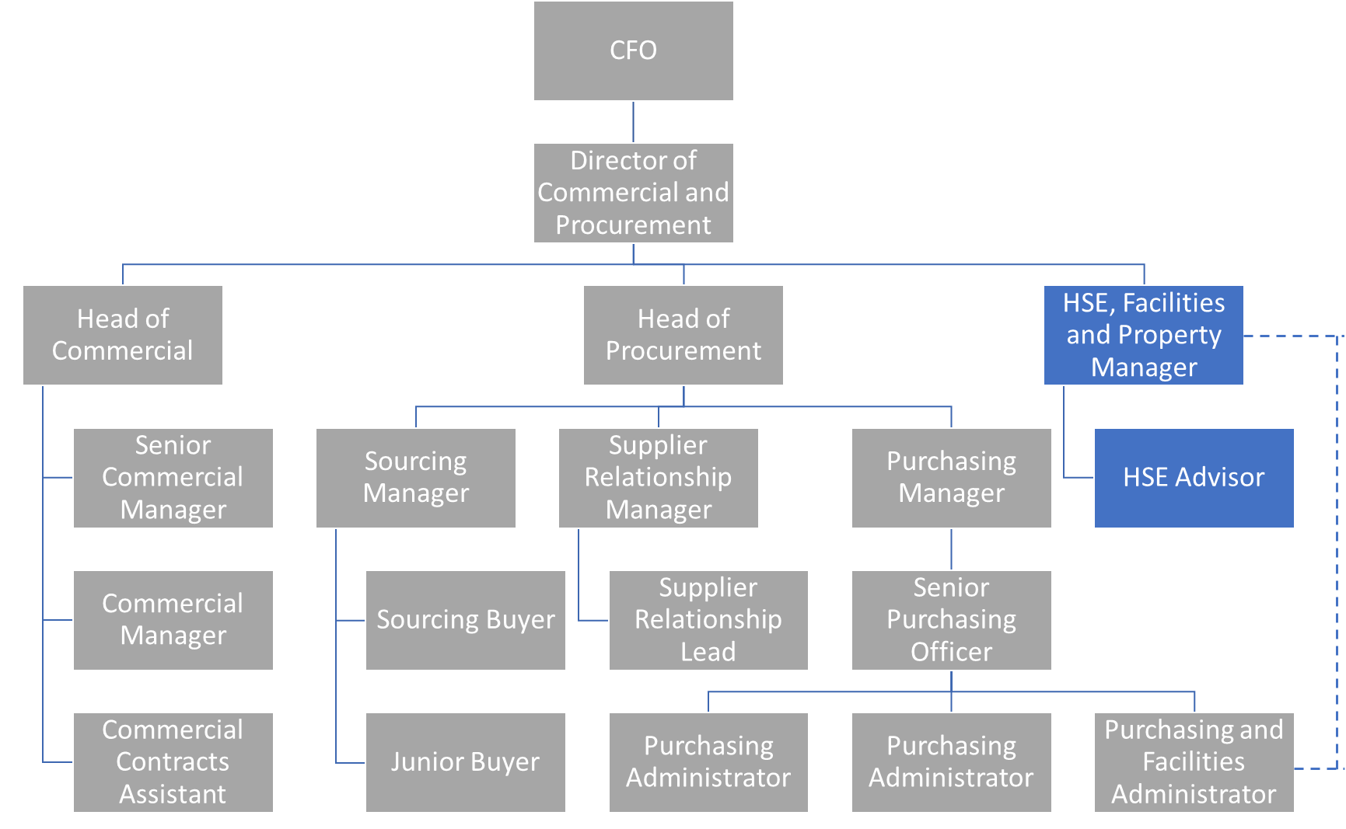

**Responsibilities**

* Investigating of accidents and ensuring all documentation is updated
* Implementing of any new legislation relating to health and safety
* Facilitating all forms of risk assessment - manual handling, fire risk assessments / fire prevention, COSHH
* Completing occupational health and safety surveys - noise, light
* Providing health and safety awareness training
* Performing site inspections
* Completing prevention inspections on a regular basis and ensure records maintained of same
* Performing annual H&S audits and Quality Assurance
* Ensuring suppliers accreditations such as CHAS and Safe Contractor are in place.
* Ensuring ISO standards are adhered to
* Responsible for maintaining ISO14001 compliance
* Responsible for continually improving the EMS
* Responsible for maintaining the environmental legal compliance register
* Leading on regular quality and environmental reviews
* Leading the overall ESG agenda
* Leading the property strategy

**Accountabilities**

* To maintain NHSP ISO 14001 accreditation
* To ensure Trust services site risk assessments are complete each year
* Ensure all First Aider and Fire Marshall responsibilities are carried out as per agreed policy and procedures
* Compliance: Achieves Health and Safety audit scores of 100% across our offices
* Environmental improvement: Leading NHSP towards a greener, more efficient estate including energy performance improvements as well as implementing a plan which ensures a more environmentally friendly and conscious approach to running our services
* Manage the development and implementation of environmental management systems within the organisation by identifying, solving and alleviating environmental issues, such as pollution and waste treatment, in compliance with environmental legislation

**Key Values:**

In addition to undertaking the duties as outlined above, the job holder will be expected to fully adhere to the following:

* **Equality and Diversity**

To act in accordance with NHS Professional’s Equality and Diversity Policy, this is designed to prevent discrimination of any kind.

* + **Health and Safety**

Ensure that all duties are carried out in line with NHS Professional’s Health and Safety Policy.

* + - **Corporate Image**

Adopt a professional image at all times.

* **Risk Management**

Responsibility for reporting complaints, incidents and near misses through the Complaints and Incidents Management System (CIMS)

Responsibility for attending health and safety training as required.

Responsibility for assisting in risk assessments.

* **Scheme of Delegation**

To comply the Scheme of Delegation this requires any employee to declare an interest, direct or in-direct, with contracts involving the organisation.

**Note:**

This job description outlines the roles, duties and responsibilities of the post. It is not intended to detail all specific tasks.