**Job Description**

**NHS Professionals Limited**

|  |  |
| --- | --- |
| Job Title: | Strategic Sourcing Manager |
| **Band:** | SME 3 |
| **Location:** | Location Hemel/Leeds/Agile |

**Role:**

To lead and manage the strategic sourcing and contract management of a portfolio of direct and indirect categories with an annual spend in excess of £40m, working closely with SRM, Purchasing and Commercial functions, and reporting into the Head of Procurement.

Develop and implement a comprehensive category of strategies aligned to NHS Professionals (NHSP) business requirements.

**Organisational Structure:**

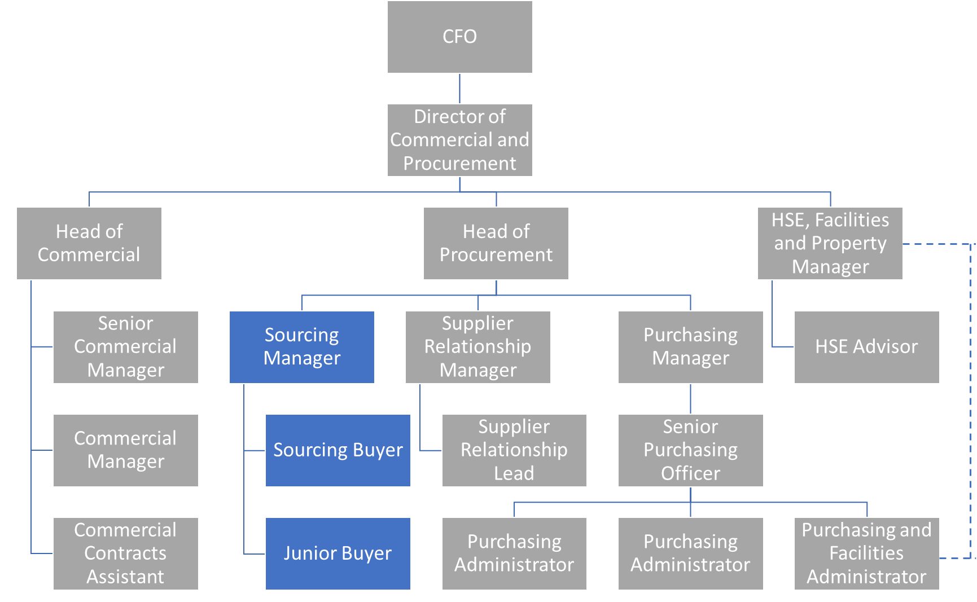

**Responsibilities:**

* Responsible for the planning and timely project management and delivery of strategic sourcing strategies for designated areas of spend
* Work collaboratively with the business to drive appropriate stakeholder engagement and ensure good information flow on sourcing activities and contract implementation
* Contract drafting and negotiations
* Authorisation and control of new products and supplier requests
* Identify and lead cross-functional opportunities both internally and externally
* Develop, agree, and communicate category strategy, objectives and implementation activities to key internal stakeholders and suppliers
* Work closely with both SRM and Purchasing, ensuring seamless and collaborative engagement and hand-offs
* Manage internal and external benchmarking of portfolio spend
* Quickly develop specific product and service knowledge of key spend areas
* Coach and develop buyers on a day-to-day basis
* Support Head of Procurement in delivery of key corporate initiatives
* Identify and implement best in class sourcing strategies and practice to achieve maximum benefits for NHSP within the defined categories
* Develop excellent relationships with key stakeholders
* Develop a clear understanding of future business requirements
* Use and champion the Arcus supplier management system, ensuring supplier profiles and the contract database are kept up to date at all times

#### Leadership and People Management:

* Ensure that all team members are aware of and adhere to all customer related policies and processes including Health & Safety, Data Protection and other legislative requirements
* Create a motivated,high-performance culture where measures are fair and consistent and failure to achieve is addressed promptly through honest conversations, support and coaching
* Ensure mechanisms are in place to identify and satisfy training needs and skills gaps to enable all individuals to grow whilst strengthening the team as a whole
* Manage team members who report to you inclusive of sickness, annual leave and appraisals
* Daily visible leadership and management of the department
* Clear direction and leadership regarding personal conduct and practice standards whilst role modelling NHSP behaviours and customer care standards consistently
* Ensuring 100% compliance of staff competence and relevant mandatory training within timescales, for your direct reports

**Accountabilities:**

* Delivery of cost savings against agreed targets whilst maintaining required levels of service
* Managing relationship with key suppliers in collaboration with SRM
* Actively engaging with key stakeholders and build good working relationships seeking to drive cost out and find value added business opportunities
* Ensure buyers adhere to professional sourcing process
* Assist buyers to define negotiation strategy and objectives and lead suppliers negotiation meetings
* Develop and implement contracts with selected suppliers
* Ensure category spend, supplier management and contract databases are kept updated
* Work collaboratively with the business and other procurement areas to share best practice and knowledge
* Track and report savings, spend and usage to business

**Note:**

This job description outlines the roles, duties and responsibilities of the post. It is not intended to detail all specific tasks.