Job Description
NHS Professionals Limited
Job Title | Purchasing and Facilities Administrator
Grade | TBC
Location | Leeds

Role

To support with the timely and accurate delivery of a high-quality Facilities service that maintains NHS Professionals properties, equipment and services to the highest standard ensuring the day to day needs of the business are met. To provide a Purchasing service, processing contractually agreed requests for purchases, in accordance with the Procurement Policy and the Scheme of Delegation and provide administrative assistance to the Procurement Team.

Organisational Structure

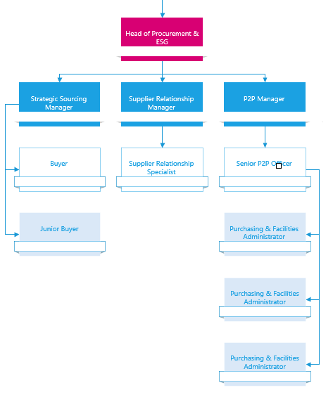

Responsibilities (Facilities)

- Support the Head of Procurement & ESG and the Health, Safety and Environmental Manager in raising the profile of the team throughout the business and actively assist in developing recognition of the benefits of the utilisation of the Purchasing & Facilities Service.
- Support an efficient and effective Facilities service, ensuring a consistent approach to identifying and addressing stakeholder requirements in accordance with Health and Safety Legislation.
- Working as a team, be the first point of contact for Facilities issues ensuring that all issues are reported on the Service desk and maintain a progress log that documents communications and remedial actions.
- Assist with the completion of annual onsite Risk Assessments for designated Trust Services Offices and report findings back to Senior Management in the agreed format.
- Hold monthly and quarterly remote meetings with the relevant Trust Services and/or Account Management representative to ensure that all potential risks are managed and/or resolved.
- Update the relevant logs/trackers for the Trust Services Risk Assessments at all stages so the information held is accurate and up to date.
- Complete daily office walkarounds to ensure all equipment is functioning as should.
- Collate and process all stationery requests for the Hub you are based in.

Responsibilities (Purchasing)

- To accurately input and maintain data onto the finance and purchasing applications, ensuring that NHSP is committed to pay the agreed value of purchases.
- Raise Purchase Orders on the Purchasing Application ensuring they are sent to the relevant budget holder for approval and forwarded to the supplier upon completion where necessary, ensuring all checks for compliance are made against the contract.
- Work with Finance Business Partners to ensure budget requirements are met.
- Receipt Purchase Orders where the goods and services have been confirmed as received and only to the level received.
- Resolve invoice queries by effectively communicating with stakeholders and suppliers, ensuring NHS Professionals pays at the agreed rate and only against received goods and/or services.
- Handling telephone and email bookings for taxis to and from our Hemel Office and validating invoices against bookings.
- Processing Display Screen Equipment orders, discussing requirements with suppliers to ensure that the correct items are ordered, delivered, and installed appropriately.
- Responsible for managing stationery orders across the organisation. This includes setting up users in our Trust Offices to ensure efficient access to office supplies.
- Booking couriers for the business where required.
- Booking meeting rooms.
- Assist with new starters being set up on our Travel Management System.
- Conducting invoice validation for travel-related spend.
- Maintain a comprehensive record of corporate uniform orders, ensuring accurate validation against the order log.

Accountabilities

- To accurately input and maintain data onto the finance and purchasing applications, ensuring that NHSP is committed to pay the agreed value of purchases
- Problems are identified, managed and resolved within an acceptable timescale.
- Engage with all supporting departments and divisions across NHS Professionals as appropriate to achieve local objectives.

Specific Knowledge, Experience and Qualifications
- Experience of using a service desk environment is desirable but not essential.
- Experience of Dynamics 365 is desirable but not essential.
- Good IT literacy including MS PowerPoint and Excel.
- Excellent written and verbal communication skills.
- Strong numeracy.
- Excellent interpersonal skills and ability to work with people at all levels.
- Prepared to travel (UK).

Key Values:

In addition to undertaking the duties as outlined above, the job holder will be expected to fully adhere to the following:

- Equality and Diversity
To act in accordance with NHS Professional’s Equality and Diversity Policy, this is designed to prevent discrimination of any kind.
  - Health and Safety
Ensure that all duties are carried out in line with NHS Professional’s Health and Safety Policy.
    - Corporate Image
Adopt a professional image at all times.
- Risk Management
Responsibility for reporting complaints, incidents and near misses through the Complaints and Incidents Management System (CIMS)
Responsibility for attending health and safety training as required.
Responsibility for assisting with risk assessments.
- Scheme of Delegation
To comply the Scheme of Delegation this requires any employee to declare an interest, direct or in-direct, with contracts involving the organisation.

Note:

This job description outlines the roles, duties and responsibilities of the post. It is not intended to detail all specific tasks.

Acceptance:

I agree to undertake the duties of the job in accordance with the above

Signed: ..…………………………………………..… (Job Holder)

Name: ……………………………………………… (Print)

Date: ……………….

Signed: …………………………………………… (Line Manager)

Name: ……………………………………………... (Print)

Date: ……………….

PERSON SPECIFICATION

Criteria: | ESSENTIAL  (When applying for this job it is important you fulfil all these essential requirements. If you do not you are unlikely to be interviewed) | HOW IDENTIFIED  A / C / I / P/ R / T | DESIRABLE  (When applying for this job it is desirable you fulfil these requirements. However, if you do not you may still apply and may be interviewed) | HOW IDENTIFIED  A / C / I / P/ R / T
Qualifications and Knowledge: | - Maths and English GCSE of minimum ‘C’ grade or equivalent.  - Understanding of the Facilities Maintenance market in order to make recommendations to improve our current service offering  - Relevant Health and Safety qualifications including but not limited to IOSH, Managing Safely  - Willingness to undergo any further training relevant to the position.  - Computer literate using Microsoft applications including PowerPoint and Excel | A and C  I |  | A and I
Experience: | - Relevant experience in a Purchasing and Facilities role  - Good working knowledge of Microsoft packages inc. Word, Excel and Outlook | A and I |  | A and I
Communication and People Skills: | - Excellent communications skills both written and oral  - Demonstrable track record in communicating ideas to senior management  - Excellent interpersonal skills and ability to work with people at all levels  - Ability to emphasise whilst maintaining a professional manner
Organisational Skills: | - Organisational skills – prioritisation of workload Ability to deal with people of all levels.  - Ability to work as part of a team and be individually motivated.
Specialist Knowledge/ Skills: | - Ability to work under pressure and meet deadlines | A and I |  | A and I
Physical Skills: | - Must pass pre-employment health assessment  - Ability to travel and visit other NHSP offices including hospital sites across the UK as required | P
Equality: | - Candidates should indicate an acceptance of and commitment to the principles underlying NHSP#s Equality and Diversity and Health and Safety Policies.
Key: A = Application Form C = Certificate I = Interview P = Pre-employment health screening R = References T = Tests/presentation

