Job Description
NHS Professionals Ltd

Job Title: | Recruitment Consultant
Grade | L2
Reports to  Location | Regional Managing Consultant  Hemel/Leeds

Role

The post holder is responsible for proactively matching and placing registered Doctors with available placements at assigned Client Trusts. A key objective is to drive and increase Doctors Direct fill, therefore the Recruitment Consultant will proactively source and match candidates to available roles. In addition, the live roles are to be updated, shared and tracked with the wider recruitment team.
Providing an efficient, professional and customer focused recruitment and placement service to locum doctors and client Trusts. Managing the bank of Doctors allocated to its clients and those part of our wider national bank.
The post-holder will work within the Doctors Direct Recruitment team providing tactical, hands-on support and be a main point of contact for the Trust’s temporary staffing functions and NHSP onsite teams. The post holder will have specific responsibility for increasing Doctors Direct fill, agency migration projects and trust specific recruitment strategies. In addition, the Recruitment Consultant will proactively work with neighbouring trusts to the aligned clients, uncovering their needs and matching suitable candidates. The primary objective is to grow aligned clients, and the surrounding trusts to the client(s).
Working with colleagues from within Doctors Direct team and NHSP onsite team, the post holder will play an active role in Agency migration, service development as well as improvement and enhancement activity linked to our Managed Service product.
The post holder will Identify, gather and collate data from multiple sources in order to effectively evaluate a trust’s current use of temporary staffing and identify opportunities.

Organisational Structure (Illustrative)

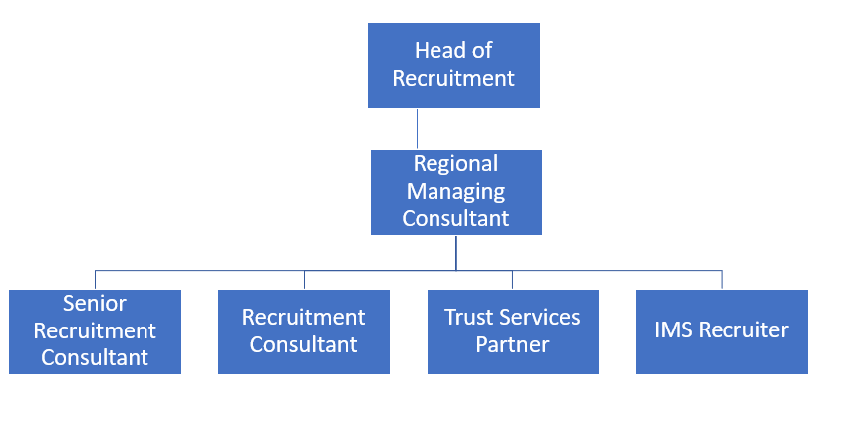

Responsibilities
- Identify, gather and collate highly complex client data from multiple sources in order to effectively evaluate a trust’s current use of temporary staffing and identify savings opportunities, as well as opportunities to increase Doctors Direct fill
- Engaging and working closely with registered Doctors to understand their availability and preferences on areas of work – matching these candidate to the aligned clients, and non-NHSP clients
- Proactively sourcing candidates, inclusive and not limited to proactively seeking referrals, advertising of live vacancies, Linkedin and contacting candidates via the database
- Matching registered Doctors with available assignments within our client Trusts ensuring they meet the required skills and experience required
- Support the Compliance Team with the engagement of registered Doctors/pipeline candidates to complete outstanding compliance tasks
- Agreeing terms of business, including margin per hour, where applicable
- Ensuring that applicants who join the doctor’s bank are managed professionally, effectively, efficiently and in keeping with NHS Professionals employment and compliance requirements and any additional checks required for the specific client Trust placements
- Visiting Client and Non-Client Trusts may be required to support with the provision of Doctors Direct Services and engagement with Doctors
- Attend external and client trust events to help promote Doctors Direct services to Doctors and both clients and non-client trusts
- Support increased shift fill by maintaining regular engagement with registered Doctors to ensure recorded availability and contact details are up to date and accurate, supporting them in identifying compatible available assignments
- Undertaking welcome calls to newly registered Doctors identifying their availability and whether there are any assignments available suitable to their availability, qualifications and experience
- Liaise with client trusts to confirm placement information or assist in the resolution of queries
- Act as the first point of contact for queries from registered doctors, escalating these where appropriate
- Develop own skills and knowledge, ensuring full understanding of team interfaces/impacts within the department and organisation
- Provide regular reporting to Team Managers on recruitment and placement activity
- Work with management team on training and developing placement officers and placement administrators. Work with the team to share best practice.
- Be flexible and willing to support placement officers/administrators with challenges/opportunities surrounding client/candidate matters
- To demonstrate effective, and professional communication skills across all areas of the business, both with internal and external clients including department managers, onsite teams and Doctors.
- Ensure working relationships are established and maintained with internal stakeholders, registered Doctors/candidates and client trusts
- Use analytical skills to interrogate data to identify opportunities where booking behaviours can be improved and then develop plans collaboratively to realise these opportunities.
- Working with the relevant stakeholders, take ownership and responsibility for the conversion of agency workers to Bank.
- Once identified and contacted by the trust engaging with agency workers to migrate them to bank – advising on pay rates and the bank application process etc
- Take ownership of staff group specific projects including staff group and DE implementations, service refreshes and recruitment campaigns, where necessary owning the end to end process.
- Contribute to the development and maintenance of systems and processes to enhance project performance
- Working with the NHSP onsite teams and the centralised team of specialist recruiters to educate both client and worker groups on our service offering and agency migration in order that both our client Trusts and flexible workers can gain the maximum benefit from these services
- Influence external stakeholders to adopt proposals and recommendations made by NHS Professionals in support of account objectives
- Build and maintain on-going working relationships with stakeholders – both internal and external at all levels across the organisation, ensuring that we are always one step ahead of our competition.
- Act as a point of contact for client Trusts for queries relating to the operational delivery of the Doctors Direct service.
- Work to agreed team, service and organisational objectives
- Meeting or exceeding Key Performance Indicators and targets
- Work collaboratively with the wider service to devise and implement innovative service developments
- To always Uphold the standards and behaviours of the NHSP way at all times

- Manages own time and workload effectively, ensuring demands and objectives are prioritised and delivered
- Delegating and liaising with the wider Doctors Direct team where appropriate to ensure client requests are met in a timely manner
- Able to be proactive when working autonomously
- Seeks solutions to resolve challenges
- Continuously looks for ways to improve processes and service offering.
- Possess communication skills to deliver/discuss options regarding service delivery, which may involve complex or sensitive information;
- To develop and maintain key working relationship across all areas of the business including the onsite teams, the specialist recruitment teams, Information and Insight teams and Marketing.
- Communicate customer needs, expectations and provide regular updates to the onsite teams relating to developments with the specialist recruitment team, particularly those which would embrace partnership working with Trust
- Attend and contribute positively to meetings as and when required
- Deal with sensitive and confidential information always ensure confidentiality of records and personal information in accordance with the organisation’s policy and provisions of GDPR

Accountabilities
- Achievement of KPIs including
- Growth of Doctors Direct bank
- Increase in percentage bank fill
- Reduction of Agency workers
- Increase client base, bu engaging with neighbouring trusts to the aligned client

Key Values:

In addition to undertaking the duties as outlined above, the job holder will be expected to fully adhere to the following:

- Equality and Diversity
To act in accordance with NHS Professional’s Equality and Diversity Policy, this is designed to prevent discrimination of any kind.
  - Health and Safety
Ensure that all duties are carried out in line with NHS Professional’s Health and Safety Policy.
    - Corporate Image
Adopt a professional image at all times.
- Risk Management
Responsibility for reporting complaints, incidents and near misses through the Complaints and Incidents Management System (CIMS)
Responsibility for attending health and safety training as required.
Responsibility for assisting in risk assessments.

- Scheme of Delegation
To comply the Scheme of Delegation this requires any employee to declare an interest, direct or in-direct, with contracts involving the organisation.
Note:

This job description outlines the roles, duties and responsibilities of the post. It is not intended to detail all specific tasks.

Acceptance:

I agree to undertake the duties of the job in accordance with the above

Signed:..…………………………………………..… (Job Holder) Name: ……………………………………………… (Print)
Dated ……………….

Signed: …………………………………………… (Line Manager) Name: ……………………………………………... (Print)
Dated ……………….

PERSON SPECIFICATION

Criteria: | ESSENTIAL  (When applying for this job it is important you fulfil all these essential requirements. If you do not you are unlikely to be interviewed) | HOW IDENTIFIED  A / C / I / P/ R / T | DESIRABLE  (When applying for this job it is desirable you fulfil these requirements. However, if you do not you may still apply and may be interviewed) | HOW IDENTIFIED  A / C / I / P / R / T
Qualifications and Knowledge: | Educated to degree level or equivalent demonstrable experience |  | - Knowledge of NHS market environment, recruitment and employment
Experience: | - Previous experience of  working in a demanding customer focused and/or sales environment  - Proficient with use of  Microsoft Office Applications including excel, word, PowerPoint and database applications.  - Experience of dealing  with high volume internal and external “customer” enquiries over the telephone, in writing and face-to-face. |  | - Recruitment within the medical sector  - Experience of undertaking project support  - Experience of working in  - the NHS  - Experience of advising and  - supporting managers with  - recruitment processes.  - Previous experience of  - working within a temporary  - staffing or recruitment  - environment  - Experience in outbound  - pro-active calling  environment.
Communication and People Skills: | Proven Skills in:  - Verbal/written communication  - Relationship building  - Assertion/persuasion  - Negotiating/influencing  - Demonstrate leadership and mentoring capabilities  - Team building/working
Organisational Skills | - Ability to manage time and workload effectively without direct supervision  - Ability to meet changing deadlines  Flexible approach to changing business needs
Specialist Knowledge and Skills | - Analysis, interpretation and manipulation of complex data / information from multiple sources  - Identification / analysis of service delivery issues  - Provision of options / solutions for resolving issues  - Researching information relevant to role  Advanced knowledge of Excel, including Pivot tables and charts and graphs
Physical Skills: | - Must pass pre-employment health assessment. | P
Equality: | - Candidates should indicate an acceptance of and commitment to the principles underlying NHSP’s Equality and Diversity and Health and Safety Policies. | I

Key: A = Application Form C = Certificate I = Interview P = Pre-employment health screening R = References T = Tests/presentation

