**Job Description**

|  |  |
| --- | --- |
| **Job Title** | Commercial Manager |
| **Grade** |  |
| **Location** | Hemel/Leeds, but some WFH, UK National travel may be required. |

**Role**

To act as a partner to the relevant business units, in particular Client Account Management and Trust Services, to assist them with their understanding of the opportunities and risks in our client contracts, with the aim of maximising opportunities and minimising risks.

**Organisational Structure**

Will report to the Head of Commercial Contracting, who reports to the Commercial & Procurement Director

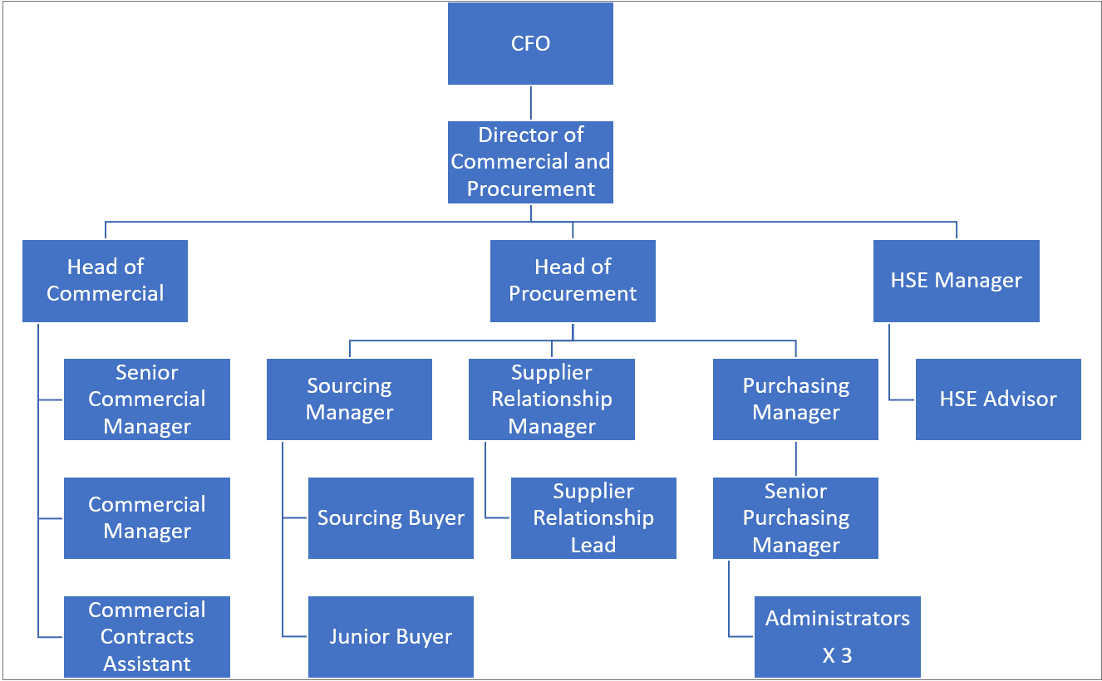

**Responsibilities**

* Ensure delivery of services at the correct standards, performance, and cost, and provide clarity on commercial dependencies and obligations on all parties.
* Develop and maintain an understanding of relevant contracts.
* Develop a strong and integral interface between the businesses and the commercial team, which encourages a better understanding and interaction between the two groups.
* Action all contract changes, ensuring change management processes are followed and commercial consequences of change are properly controlled.
* Identify and work with the business to mitigate commercial risks, contributing to the risk management plan, escalating any significant risks to the Head of Commercial Contracting.
* Identify and work with the business to realise commercial opportunities.
* Maintain awareness and contribute to contingency plans for critical contracts.
* Support commercial management and contract negotiations with senior stakeholders.
* Work with the business to ensure compliance to relevant public procurement law and commercial best practice.
* Provide effective commercial support across the business including Framework obligations and contract queries.
* Acting as the customer point of contact for contractual & commercial matters and developing close working relationships with Customers.

**Accountabilities**

* Liaise with the bid and programme management function.
* Support bids and proposal activities.
* Act as point of contact for the customer and foster strong internal relationships.
* Commercial risk and contract mitigation activities
* Provide support to ensuring client compliance with the terms and conditions.
* Be aware and provide support to ensure compliance to the framework conditions.
* Identify and support the team to mitigate commercial risks for projects and programmes.
* Managing contracts throughout the delivery, ensuring effective change management, and escalating any queries or disputes for resolution.
* Provision of advice, assistance, and guidance on a wide range of commercial matters to the business and bid team including Project Managers, Business Development Managers, Client Services & functional team members.
* Action all contract changes, ensuring change management processes are followed and commercial consequences of change are properly controlled.

**Key Values:**

In addition to undertaking the duties as outlined above, the job holder will be expected to fully adhere to the following:

* **Equality and Diversity**

To act in accordance with NHS Professionals’ Equality and Diversity Policy - this is designed to prevent discrimination of any kind.

* + **Health and Safety**

Ensure that all duties are carried out in line with NHS Professionals’ Health and Safety Policy.

* + - **Corporate Image**

Adopt a professional image at all times.

* **Risk Management**

Responsibility for reporting complaints, incidents and near misses through the Complaints and Incidents Management System (CIMS)

Responsibility for attending health and safety training as required.

Responsibility for assisting in risk assessments.

* **Scheme of Delegation**

To comply with the Scheme of Delegation - this requires any employee to declare an interest, direct or in-direct, with contracts involving the organisation.

**Note:**

This job description outlines the roles, duties and responsibilities of the post. It is not intended to detail all specific tasks.

|  |
| --- |
| **PERSON SPECIFICATION** |

|  |  |  |  |  |
| --- | --- | --- | --- | --- |
| **Criteria:** | **ESSENTIAL**  *(When applying for this job it is important you fulfil all these essential requirements. If you do not you are unlikely to be interviewed)* | **HOW IDENTIFIED**  A / C / I / P/ R / T | **DESIRABLE**  *(When applying for this job it is desirable you fulfil these requirements. However, if you do not you may still apply and may be interviewed***)** | **HOW IDENTIFIED**  A / C / I / P / R / T |
| **Qualifications and Knowledge:** | • Experience in commercial management within the public sector   * Good understanding of the UK public sector procurement rules | A/I | * Degree educated |  |
| **Experience:** | * Procurement Process - Experience of public sector procurements. | A/I  A/I | * Previous employment in the recruitment sector | A/I |
| **Communication and People Skills:** | * Builds Relationships - Confident in managing strategic relationships, including leading on meetings and negotiations. * Assertive - Strong communication skills. * Excellent listening skills with an ability to work with various people. * Professional honesty and integrity in dealing with colleagues and clients | A/I  A/I |  |  |
| **Organisational Skills** | * Ability to motivate self and manage own time. | A/I |  |  |
| **Specialist Knowledge and Skills** |  |  | * Understanding of how Public Sector Framework contract work | A/I |
| **Physical Skills:** | * Must pass pre-employment health assessment. | P |  |  |
| **Equality:** | * Candidates should indicate an acceptance of and commitment to the principles underlying NHSP’s Equality and Diversity and Health and Safety Policies. | I |  |  |

Key: A = Application Form C = Certificate I = Interview P = Pre-employment health screening R = References T = Tests/presentation